**SEP1Y Group 6 Final Project**

**PROCESS REPORT**

Daniel Lopes Adrião, 315274

Dragos Daniel Bonaparte, 315261

Laura do Bem Rebelo, 315174

Matas Armonaitis, 315263

**Supervisors:**

Steffen Andersen (SVA), Mona Andersen (MWA)

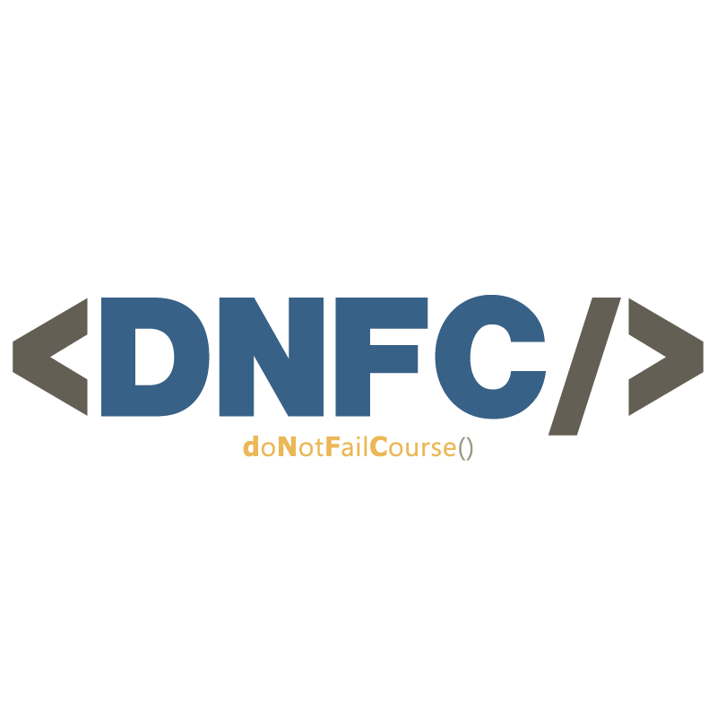

**30.310 characters**

**Software Technology Engineering**

**1st Semester**

**15.12.2021**

**Table of content**

1 Introduction 1

2 Group Description 2

3 Project Initiation 4

4 Project Description 5

5 Project Execution 7

6 Personal Reflection 9

7 Supervision 18

8 Conclusions 19

9 Sources 20

# Introduction

Group 6 from class Y, composed of Daniel Lopes Adrião, Dragos Daniel Bonaparte, Laura do Bem Rebelo and Matas Armonaitis worked together throughout their first semester, autumn 2021, for the course SEP1.

A recollection of their meetings throughout the Project Period can be assessed in the following table:

|  |  |
| --- | --- |
| 29/11 | * **START OF PROJECT PERIOD.** |
| 30/11 | * Met from 13:00 – 17:00. |
| 1/12 | * Met from 10:00 – 15:00. |
| 2/12 | * Met from 13:00 – 16:00. |
| 3/12 | * Met from 13:00 – 16:30. |
| 4/12 | WEEKEND |
| 5/12 | WEEKEND |
| 6/12 | * Met from 13:00 – 17:00. |
| 7/12 | * Met from 11:00 – 16:00. |
| 8/12 | * Met from 10:00 – 15:00. |
| 9/12 | * Met from 10:00 – 15:00. |
| 10/12 | * Met from 12:00 – 16:00. |
| 11/12 | WEEKEND |
| 12/12 | WEEKEND |
| 13/12 | * Met from 13:00 – 17:00. |
| 14/12 | * Met from 10:00 – 12:00, 14:00 – 16:00. |
| 15/12 | * Met from 10:00 – 16:00. |

The logbook for this group can be found in more detail in APPENDIX 1C LOGBOOK. As for the tuition period, it contains information about what assignments and parts of SEP were done in each week, and as for Project Period, it contains more detailed information about what was accomplished on each day in terms of Implementation and Documentation of the Semester Project.

Only one supervisor meeting was held on the 10th of December at 14:20 with Mona Andersen, of short duration (about 20 minutes).

# Group Description

For a four-person group, our group has a fair amount of diversity, both culturally and experience-wise. We feature two students from Portugal: Daniel and Laura, one from Romania: Dragos, and one from Lithuania: Matas, all with different programming backgrounds.

**DANIEL LOPES ADRIÃO**

**NATIONALITY:** Portuguese

**PRIOR EXPERIENCE:** Three-year programming course, internships related to that subject, some personal projects



**DRAGOS DANIEL BONAPARTE**

**NATIONALITY:** Romanian

**PRIOR EXPERIENCE:** C++ in High School

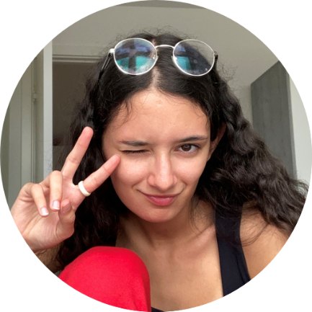

**LAURA DO BEM REBELO**

**NATIONALITY:** Portuguese

**PRIOR EXPERIENCE:** 1 semester of Python

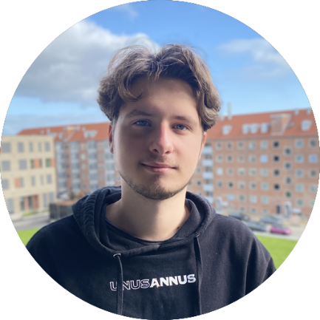

**MATAS ARMONAITIS**

**NATIONALITY:** Lithuanian

**PRIOR EXPERIENCE:** C++ in High School

# Project Initiation

As for how it all began, our group was formed quite occasionally: we were two pairs of people: Daniel & Laura and Dragos & Matas. Both pairs were looking for another two people to team up with in order to achieve a group of four members, so it was purely by chance that we came to be <DNFC/>.

<DNFC/> is the name of our group. It stands for “Do Not Fail Course” – which started out as a joke, but we gradually became so fond of it that it became our group name. However, it is not to be misunderstood: our goal is not merely to pass the course, but to pass it with a high grade by bringing out the best in each other and presenting high quality work.

The prompt for this project was a case presented to us, for which we had to produce a solution. The case in question is explained in detail in the Project Description – APPENDIX 1A, but in summary: VIA’s timetable manager was looking for a tool that would facilitate his job of creating timetables, and we had to develop a Java application and design a website to fulfill that need.

Regarding “planning” in order to execute our project work, our planning was often light and casual. Initially, we merely followed what was asked of us: write a Project Description, make an Analysis Document, design our program, etc. But as soon as we were on our own, the one dogma that we followed was solely to set our priorities straight and make sure to make progress each time we met. This way, if we kept meeting regularly, we could make sure that our project would keep moving forward, and that it would be finished sooner or later. By “setting our priorities straight”, what we mean is that it we made it our number one priority to get down the most critical requirements, as opposed to getting stuck on details that would not make that much difference in the final product. Only after the “foundations” had been concluded did we allow ourselves to dive into detail on what could be improved – polish our work. This approach proved itself to be successful: although the project period was stressful and demanding, we were always able to stay on track and did not struggle to meet the deadline. This is extremely positive, because working in a rush could have led us to sacrifice the quality of our project in order to “save time”, and the fact that we had a comfortable time margin made it possible for us to excel in our performance.

# Project Description

It would be a lie to say that our Project Description was a smooth start. As first semester students, we were not familiar with neither Waterfall nor Report Writing. This meant that as soon as we were presented with the case, we started thinking about “how to implement it”, instead of having a structured approach to project work. Of course, as soon as we became aware of what was expected of us, we stopped, slowed down and took the time to write an appropriate Project Description. This meant focusing exclusively on the problem and not on the solution. We then realized that it is crucial to first understand the problem before considering how to approach it and solve it. Moreover, the fact that SEP encourages so much autonomous work is directly related to Problem-Based Learning: by giving us so much responsibility, this course promotes independency, is highly engaging and feels extremely rewarding (What is Problem-Based Learning (PBL) | Hun School of Princeton, 2021).

At the beginning, we set out different goals: the bare minimum was to pass the course, as our group name would suggest. However, that would not be enough for us to be satisfied: so, when drawing up a group contract, we collectively agreed that we would work hard in order to achieve a high, fulfilling grade, in order to start the Software Technology Engineering Programme on the right foot.

On a more technical note, the goals that we set out for our program were not realistic at the start - we were a bit too ambitious with what we could do with the amount of time and knowledge that we had in our possession. For example, we wanted the system to be able to provide timetables individually for each student, but it ended up only supporting timetables for whole classes (1X, 1Y…). Still, the broader goal was to successfully develop a working Java application featuring a responsive website that could read from an XML file, two things we managed to achieve. This will be discussed in more detail in the following chapter.

# Project Execution

In order for our project to consistently move forward, it was required for us to follow a methodology. As first semester students, we were expected to vaguely follow the Waterfall method, so we made that our starting point. We began by drafting up a Project Description, an Analysis Document, followed up by designing our program carefully, and only then allowed ourselves to dive into Implementation. However, it was solely at the latter stages that we realized the flaws of this method: it is impossible for one to accurately predict how further stages of development will progress, meaning that when we got to the end of the Implementation phase, our Analysis and Design drafts had become outdated – therefore, it was necessary for us to redo them in order for our Project Report to be coherent.

Nevertheless, the step-by-step approach suggested by Waterfall was a good start. Although not all of the initial ideas came through in the end, our Analysis and Design documents were a good foundation for the product developed, and for this reason do we consider that following the Waterfall methodology was successful. Besides, redoing Analysis in a “backwards” manner was not hard at all. When all the use cases had been implemented, it was easy to describe them and draw up their activity diagrams.

On a more personal note, if we are to assess our conflict escalations by *Glasl's Nine-Stage Model Of Conflict Escalation*, we would say that we never got past stage 1: *Hardening*. This is because the threshold for stage 2 is when “one or both counterparties lose faith in solving the problem through straight and fair discussions” (flixabout.com, 2021). It never got to this point for us – our discussions were always constructive, respectful and fair, and the involved counterparties never doubted each other – only disagreed on how to approach the issue at hand.

As for how we chose to work together, the work style selected by our group was similar to the fourth one from the *“How to work together.mp4”* video in the Effective Teams learning path inside of the SEP1Y Course, *itsLearning (Wærn, 2021)*. The work style described in the video is based on working as sub-teams to complete different tasks. This way, it is possible to learn from different people and simultaneously get a lot of different work done. Our approach relied a lot on pair work. The pairs formed were often Daniel and Laura, and Dragos and Matas. Still, although we were working separately, we were all in the same room for group meetings and could ask any group member for help at any time.

# Personal Reflection

**Laura Rebelo**

This project taught me a lot. During my past education, every task assigned to us was always done individually and rarely ever as a group. However, in SEP, we were forced to break out of our shell, learn to work as a team, and place our trust on others. This was a bit of a challenge for me, as I tend to like to have everything my way. In fact, this is something that I wish to improve on my next Semester Project: throughout SEP1, I sometimes worked outside of “meeting hours” in ways that made the project move forward. This alone is good - but what was not so positive was that, afterwards, I did not always make sure that I went through every detail of what I had done with the rest of my group members. This is negative in a sense that, if not everyone has knowledge of everything that has been done, further progress can be hindered. Next semester, I hope that I can be more transparent with my work in order for my group members to be able to build on top of what I have worked on, instead of me inadvertently assuming the “monopoly” of a certain aspect of the program only because I have chosen to work overtime on it.

As for motivation, I believe our group felt motivated throughout the whole project period. No one ever skipped meetings without a critical reason, and we always made great progress every time we met. Group members also frequently seeked out to do useful tasks on their own, which never failed to bring the project closer to completion.

Personally, my only “demotivator” was just the overall feeling of burning out after working on the project after two, three weeks. Nearing the end of the project period, I started often feeling tired and finding myself wishing that it would be over as soon as possible. During this stage, my motivation shifted from doing it because it was enjoyable and stimulating to doing it because there was a deadline to meet and I wanted to pass the course. In other words, it became a lot less intrinsic and a lot more extrinsic due to exhaustion.

On another note, I would say that the group contract did not play a big role in defining our team dynamics. Since all of us were motivated towards the same goal and rarely ever slacked off, there was never the need to ever bring up the contract. Still, we did live up to its contents: respected each other, helped each other and always made the project move forward to the best of each of our abilities.

After SEP, I believe more than ever that group work and problem-based learning are exceptional ways of learning. Through group work, we are able to learn from each other and teach each other – two things that are really effective at making knowledge sink in deeply and not just superficially (Fiorella and Mayer, 2021). As for problem-based learning, there is much that can be said about it. It is not easy. For someone who is used to sitting back, listening to lectures and merely doing notebook exercises, it is a big leap and a big change that one might not always be ready to handle. However, I believe that it is when we struggle that we are pressured to learn the most (Boaler, 2021), and I can confirm that amidst the struggle felt throughout this Project Period, I inherently learned a lot about teamwork, about programming and about JavaScript.

**Dragos-Daniel Bonaparte**

This project just proved to me that even tough I have some experience in programming, things might still get complicated and weird. The most difficult part was to create de GUI part of the program because it was a newly acquired knowledge. The content of the group contract was pretty much respected throughout the project and everybody did whatever it was necessary to achieve a common objective. Throughout the project I in cooperation with my groupmate Matas, we created all the GUI methods and everything that was needed for the GUI to display and to make everything work the way that is intended. After everything was displaying and working Laura helped us implement the logic into the GUI, we made the buttons functional and started to think about how to schedule everything based on the input from the GUI. Basically, me and Matas worked on the creation of the GUI and on the translation of the user input to data that can be processed and used to create timetables.

The group contract had a huge success because whenever we were getting stuck in a situation, maybe one of us knew what was the problem and that helped us resolve the problems on the go without wasting too much time on the problem. Everybody worked on the same thing at the same time, for example when we were designing the program everybody was giving suggestions and everybody was designing a window. The strategy of working together on the same thing worked like a charm and helped us surpass checkpoints after checkpoints as the day passed by.

I suggest that we first create a modular checklist where we all can see what it’s needed for the project and we assign a plan on how to achieve all of this. Organizing by days or in another way. For example, let’s say that we want to create the module of the program, we create together the Astah diagram and to assign to each of us a number of methods to complete until the next day. This way, everybody knows what to do and will know how to use those classes. Currently the module was primarily made by Laura and because of that, me and Matas found it difficult at some times to access some classes or variables because we didn’t know a lot about them, which resulted in us needing to study the module first then start create functionality for the GUI.

Nobody worked more than others, we worked an equal number of hours and we valued our skills which resulted of us managing to move forward fast. As me and Matas had experience in C++ we started with the GUI and as Laura had experience in phyton she started with the module, Daniel helped us a lot in HTML because of his experience with using javascript and JQuery we managed to create a very responsive website that can read our XML files and display them and a very well-made table.

The thing that motivated the group most was that we wanted to prove to ourselves that we are capable of creating a desktop application that is of good quality and easy to use. The thing that demotivated us from my perspective was the lack of a task list, we knew what we did but sometimes you’ll get confuse and don’t know what exactly needs to be done in order to advance with the project.

I learned to be out of my comfort zone for an extended amount of time and I managed to grow a system in which I can tell to my group what bothers me about the project. I learned to communicate more and to ask for help whenever I need it. The biggest challenge I had was to get used of working with others, I am used of coding alone in my house and thinking to everything alone. At first I just couldn’t get the hang of it, I was feeling uncomfortable when wanting to look for tutorials and information around the internet on how to code something more complex because of a small anxiety I have.

I will try to stand out more the next group project we have and to get more involved in the group arguments.

The advantages of group work are that you don’t need to pull everything off by yourself, the amount of stress you have is smaller and way more manageable. I did a lot of problem-based learning in high school so for me personally it didn’t have as much of an impact as in others, but it is good that we don’t bother to much of discussing the problem, but rather start diagnosing the problem and resolving it.

The disadvantages of group work are that you don’t have the same thinking when it comes to coding something which means that you need to be very adaptive when it comes to coding style. I didn’t find yet a disadvantage for me in problem-based learning.

I think that by creating a problem formulation you understand more what exactly needs to be done in order to resolve that problem. The con of creating a problem formulation is that it might also confuse you at some point and often make you misunderstand the problem.

By creating a project description you’re writing everything you did in coding and how you thought the application in human language that everybody can understand. I think is a very good thing because it also makes the customer aware of what exactly is happening in the background. The con of creating a project description is that it takes a lot of brain power and a lot of time to create a quality one.

**Matas Armonaitis**

This project was an interesting experience and really made me learn a lot of new things. I had experience in programming in my high school, but we never had projects of this scale, also I was learning c++ not java. I learned a lot of new tricks and methods how to create a program and for that I am also grateful to my group members who helped me with some things I could not understand myself.

I did not have a lot of experience working in groups before this project so a lot of what we did was new to me. I really liked that we all agreed on when the group meetings should be, even though some of us sometimes are a little late we never address that being late is a problem which made things less stressful. We all had different backgrounds in the work we did, and I would say that’s a good thing since we could arrange our work accordingly. For example, Daniel is very experienced in web design, and he did most of the website related stuff, me and Dragos had some programming experience, even though it was not a lot, it really helped in creation of the program. Laura has very good English skills and did most of the writing in the documentation and a lot of the program writing as well. Even though we arrange our work depending on the background the work was not spread out evenly, especially in the program coding period, even though we worked the same number of hours in the group meetings. I feel that for the next time we should spread the coding more evenly since it is hard to help someone or to add something to the program without a lot of knowledge of what has been already done and how it is done.

Putting all the work-related stuff aside, the group environment I feel is good. We never had arguments, we had discussions with valid arguments and always came out with one way to do things or a compromise, that way we would not have any bad feelings in the group. We do breaks usually when we feel like we need a break which makes me feel very free in while working. During breaks we either talk about random things just to get our minds off the project or go to eat. We all have a similar goal to our project and that helps us not to push each other more than we want to. Even though we are from different countries and different cultures somehow it does not feel like it separates us. We usually have music playing in the background while we work and even though we listen to different genres of music, we have some that suits us all. Music itself made the working environment feel more laid back and we all kind of “vibe” together.

This project also made me learn a lot about myself. I learned how much work I can take, learned how much more productive I am in a friendly and focused environment, learned new ways to approach a problem and probably most importantly how to cooperate with my group. I learned that talking and discussing problems helps a lot to do the work faster.

Even though we cooperated a lot during project period, for the next time I think we should distribute the work more evenly instead of some of us taking more work than the others. Because this time I do not feel as I did as much work as the others, but not because of lack of motivation, but simply that some of the work was done when not on the group meetings.

Big advantages of group work are that with more people big projects can be done very quickly, also if someone gets stuck on some part, they cannot go solve by themselves, they can always receive help.

Disadvantages of group work is that work can sometimes be confusing, especially when trying to help someone with their problem. Also, if the group does not cooperate the work can be very unfocused and without the same path towards the objective.

Advantages of problem-based learning are that when we already know the problem, we can start discussing how to solve it head on instead of wandering what the problems could be.

The Disadvantage of problem-based learning is that some deeper things can be not addressed when solving something and starting from a problem.

Problem formulation is very important for the work since when already the problems having laid out, we can start solving them head on.

Project description is essential for big project since it gives the overall description of the work that is done or going to be done, also helps to keep the people working on the project to have the same goal.

**Daniel Lopes Adrião**

Even though I had some past experience with programming, this project taught me a lot especially about documentation and working on the group since until the start of this project, I almost only worked alone.

One of the most difficult parts to understand was the creation of the GUI because it was so new for us and also I was used to windows forms and I was expecting to be closer to that but it turns out it's different in a lot of aspects.

One of the top things about our group was that everyone helped everyone with everything. That made it so that everyone knows every single aspect of the project and how it was done. Another thing I really enjoyed about the group was the meetings because we could find time to focus but to laugh too and I'm sure that's one of the reasons we were always motivated for the next one.

About the group contract, it was very nicely written and fair but with time we didn't use that often since everyone had the same goals and motivation to work so we just did our best and did not follow the contract line by line what turns out as a great result after all.

Putting work aside, the group itself was really wonderful, we always understood each other needs and helped in every sense, also one of my favourite things was the background music because every time there was someone playing music to keep the flow and we always made a way that everyone likes the chosen songs and sometimes sing together too, also the breaks for lunch together were always very nice so we could have some free time to talk about us and our lives outside here what made us closer than before.

Even though I can say that everything was amazing there is the only thing it could be better but I'm sure it will be "fixed" for the next project, which was the distribution of work, there was some meeting that I felt lost or didn't have anything to work on and in that times I felt a bit useless but as I said it was only in some meetings.

After the first SEP, I can say that one of the advantages of problem-based learning is that when we go through a problem we really learn with it, why it happens and how to fix it and it really makes us understand better but in the same way, there is an advantage that sometimes we get a lot of time stuck in the same problem and can't seem to be fixed, of course, it eventually is but sometimes can be stressful.

The project description is a really important step on every project because it gives not only a summary about what it's done but how it was done and after a while, it's always important to understand we took a step and how and why we did it like that.

# Supervision

Supervision was a crucial aid for us in developing this project. Although we did not frequently have meetings with our supervisors, we contacted them through e-mail quite often – almost every working day.

Our criteria for reaching out was to do it whenever we felt stuck on something that we could not figure out on our own. This would include questions about implementation in Java or JavaScript, solving errors for which we could not find a solution online, or documentation-specific requirements. We were always satisfied with the reply received from our supervisors – they were straight to the point and exactly what we were looking for, meaning they helped us overcome the obstacles that were hindering our progress. Were it not for them, we might not have been able to reach a satisfactory working end product.

# Conclusions

If we are to sum up what we learned from this Project, the main takeaway was related to teamwork. Most of us were not used to working in teams or pairs before coming to Denmark, and this experience broadened our horizons and made it easier for us to trust others in a work-related environment. Additionally, by being presented with a problem and being prompted to solve it autonomously without a tutorial or guide to follow, we gained deep knowledge about programming in Java and about JavaScript.

Next semester, we are inclined to stay in the same group. Knowing this, and in order for everyone in the group to have a better SEP experience in a sense that no one feels overworked nor underworked, we will try to be more organized and transparent with our tasks. This could mean splitting tasks more evenly, and this way, the workload for each group member will be evened out.

# Sources

Boaler, J., 2021. Why Struggle Is Essential for the Brain — and Our Lives - EdSurge News. [online] EdSurge. Available at: <https://www.edsurge.com/news/2019-10-28-why-struggle-is-essential-for-the-brain-and-our-lives> [Accessed 14 December 2021].

Fiorella, L. and Mayer, R., 2021. The relative benefits of learning by teaching and teaching expectancy.

Hunschool.org. 2021. What is Problem-Based Learning (PBL) | Hun School of Princeton. [online] Available at: <https://www.hunschool.org/resources/problem-based-learning> [Accessed 14 December 2021].

Wærn, M., 2021. How to work together. [video] Available at: <https://vimeo.com/558004312/bdb1c0229e> [Accessed 15 December 2021].

**Appendices**

APPENDIX 1C – Detailed Logbook

|  |  |
| --- | --- |
| **Time period** | **What was done** |
| Week 40 | * First draft of **Project Description** |
| Week 41 | * Feedback from Partner Group & Supervisor**: POLISHED PROJECT DESCRIPTION** * First RWD Assignment (Unresponsive Website) * Fifth DMA Assignment (Algorithm Analysis and Big O) |
| Week 42 | HOLIDAY |
| Week 43 | * Started **Analysis** part 1 (Requirements & Use Cases Descriptions) * Fifth DMA Assignment (Algorithm Analysis and Big O) |
| Week 44 | * Second RWD Assignment (Responsive Website) * Sixth DMA Assignment (Binary Trees) * Feedback from Partner Group & Supervisor: **POLISHED ANALYSIS DOCUMENT** |
| Week 45 | * Seventh DMA Assignment (Sets, maps, hashing and sorting) * Started **Analysis** part 2 (Activity Diagram & Domain Model) |
| Week 46 | * Seventh DMA Assignment (Sets, maps, hashing and sorting) * Finished & handed in Final Analysis Document. |
| Week 47 | * Third RWD Assignment (JQuery) * Eighth DMA Assignment (Graphs) * Presentation about design. * Designed Class Diagram. |
| 29/11 | * **START OF PROJECT PERIOD.** * Had DMA class about Graphs. |
| 30/11 | * Met from 13:00 – 17:00. * Designed GUI. |
| 1/12 | * Met from 10:00 – 15:00. * Created GUI on Java FX. |
| 2/12 | * Met from 13:00 – 16:00. * Implemented most of the Model Classes inside Java Application. * Implemented View Controllers. |
| 3/12 | * Met from 13:00 – 16:30. * Polished classes: improved their “reusability” * Implemented extra classes * Got started on persistence (loading and saving, to and from txt and xml files) |
| 4/12 | WEEKEND |
| 5/12 | WEEKEND |
| 6/12 | * Met from 13:00 – 17:00. * Improved choice boxes inside Schedule Session window. * Implemented “Schedule Session” use case. * Implemented the Search function in “Reschedule Session” window. * Minor fixes. |
| 7/12 | * Met from 11:00 – 16:00. * Implemented the Search function in “Manage Students” window. * Minor fixes. * Changed persistence from XML to JSON. * Website can now read XML file with information about Sessions. * Website can now display timetable imported from XML file in a responsive table. * Implemented “Cancel Session” button. |
| 8/12 | * Met from 10:00 – 15:00. * Added a Pop-up to Switch a Student’s class. * Started Javadoc. * Website nearly finished. * Implemented check for Classroom overlaps. |
| 9/12 | * Met from 10:00 – 15:00. * Continued Javadoc. * Made Algorithm Time Complexity Analysis. * Implemented Switch a Student’s Class. * Finished implementing Rescheduling of a Selected Session. * Fixed bug in the website where End Time of Sessions was displayed incorrectly. |
| 10/12 | * Met from 12:00 – 16:00. * Program is basically working. Only minor fixes left. * Redid Analysis document according to existing system. * Outlined what needs to be done for Documentation. |
| 11/12 | * Got started on Project Report. |
| 12/12 | * Got started on Process Report. |
| 13/12 | * Met from 13:00 – 17:00 * Made User Guide. * Made major merge in code. Code is finished. * Minor changes to the website: added arrows for navigation between weeks. * Progress on Project Report and Process Report. |
| 14/12 | * Met from 10:00 – 12:00, 14:00 – 16:00 * Made Installation Guide. * Finished Project Report. * Finished Process Report. * Organized Appendices for Hand-in. |